School of Digital Media & Infocomm Technology (DMIT)
ST1011 Applications Development
Practical 4
Intro to Windows UI Programming

Objectives:
After completing this lab, you should be able to:
- Create a graphical user interface with Windows Forms

- Create the form for practical 2 question 1 as follows:

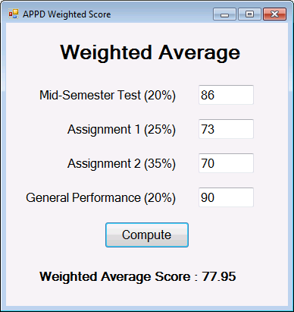
txtMst
txtGP
txtAsgn2
txtAsgn1
btnCompute
lblAverage

When the user clicks Compute button, the program accepts all the 4 input values and use the values to compute for the weighted average score using the following formula:

(MST x 0.2) + (Assignment 1 x 0.25) + (Assignment 2 x 0.35) + (GP x 0.2)

The score is then displayed on lblAverage label object.

- Create the windows form for practical 2 question 8 as follows:
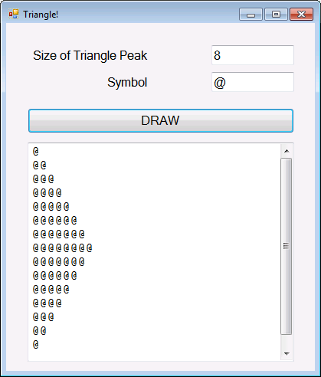
txtPeak
txtSymbol
btnDraw
txtOutput

Take note of the following:
- The program must verify to ensure that the user enters valid input values into the program. A number is required for triangle's peak and a character (only 1 character) is allowed for the symbol). When an invalid input is detected, one of the following error messages is displayed (depending on the cause of the error):
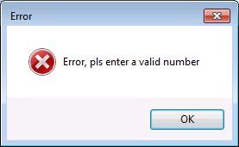 | 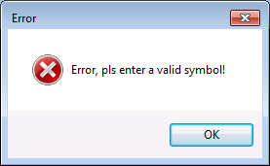
- txtOutput textbox supports multiple lines of text. To enable this function, set Multiline property to True and set ScrollBars Property to Vertical (using Properties Windows).
- The escape-character for 'carriage return' (new line) in multiline-textbox is "\r\n".
- You are encouraged to break down the program codes into 2 or more methods.
3. Create the following hotel booking application:

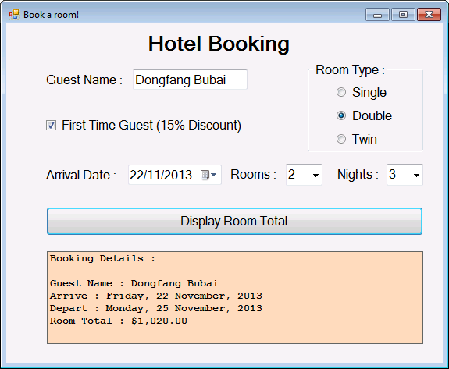

Take note of the following:
- Room Rates are as follows:
Single: $150 per night
Double: $200 per night
Twin: $210 per night
- Use DateTimePicker object for Arrival Date (you are required to do research on your own on how to use this object. Google is your best friend here!).
- Rooms and Nights combobox objects contain numbers from 1 to 9. In other words, guests are allowed to book up to 9 rooms for up to 9 nights.
- If First Time Guest checkbox is checked, 15% discount will be applied to the room total.
- Once Display Room Total button is clicked, the booking Details will be displayed on a label object. Set AutoSize property to False, and BorderStyle to FixedSingle. Choose any background color you like.
- Use appropriate name for each object on the form (follow the recommended naming convention).

- END -

